Half Yearly Progress Report on Research Work carried out from 28.09.2017 to .03.2018
Name and address of the candidate : P. Mohandass
Reg. No. P8851
PG and Research Dept. of Chemistry
Saraswathi Narayanan College
Madurai-22.

Occupation if any and address : Associate Professor of Chemistry
Saraswathi Narayanan College
Madurai-22.

Name, designation and address of the : Dr. K. Radhakrishnan
Guide PG and Research Dept. of Chemistry
Associate Professor of Chemistry
Saraswathi Narayanan College
Madurai-22.

College where the candidate carried : PG and Research Dept. of Chemistry
out the research Saraswathi Narayanan College
Madurai-22.

Whether the candidate has paid annual
Research fee (mention amount, date of :
remittance, place of bank, etc.)

Detailed one page report on the progress : Separate sheet Attached
of research work carried out by the
candidate (attach separate sheet)

Remark, if any by the guide : Nil

Signature of the candidate Signature of the research supervisor

Half Yearly Progress Report on Research Work carried out from 28.09.2017 to .03.2018
Cyclic voltammetry reduction of (E)-1-(furan-2-yl)-3-phenylprop-2-ene-1-one gives two separate irreversible one-electron peaks. A mechanism involving two separate addition of single electron has been suggested. Correlations have been made with the E_{p} and E_{p1/2} of the first peak of 4′-substituted (E)-1-(furan-2-yl)-3-phenylprop-2-ene-1-ones with substituent constants separately.
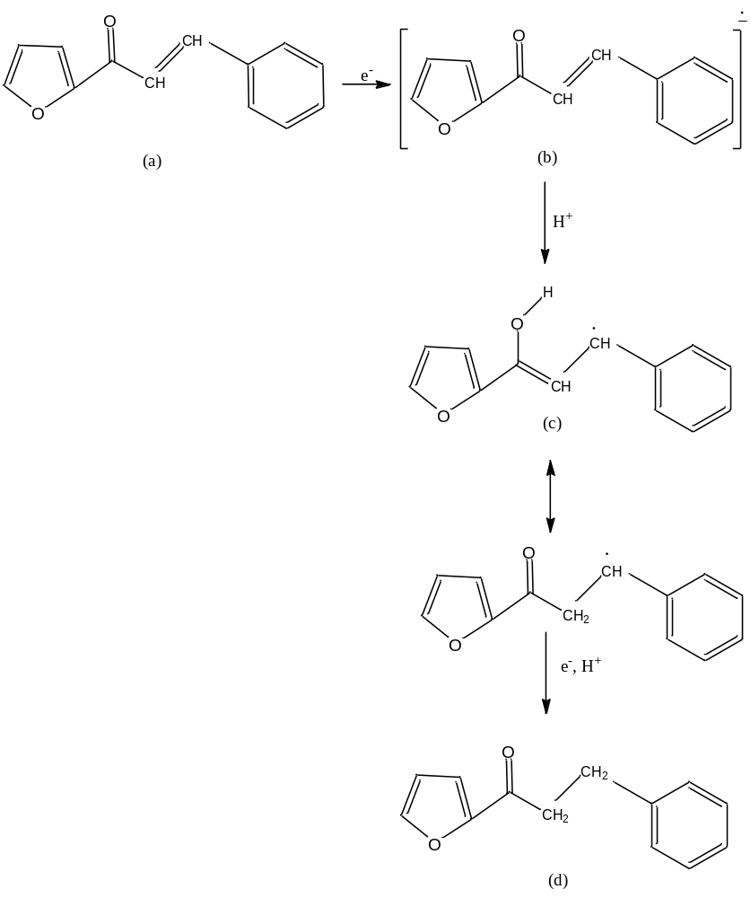

Signature of the research supervisor

